GUIDELINES FOR REGISTERING AND ACTIVATING
BIDV SMART OTP VIA BIDV SMARTBANKING
1. Register BIDV Smart OTP online
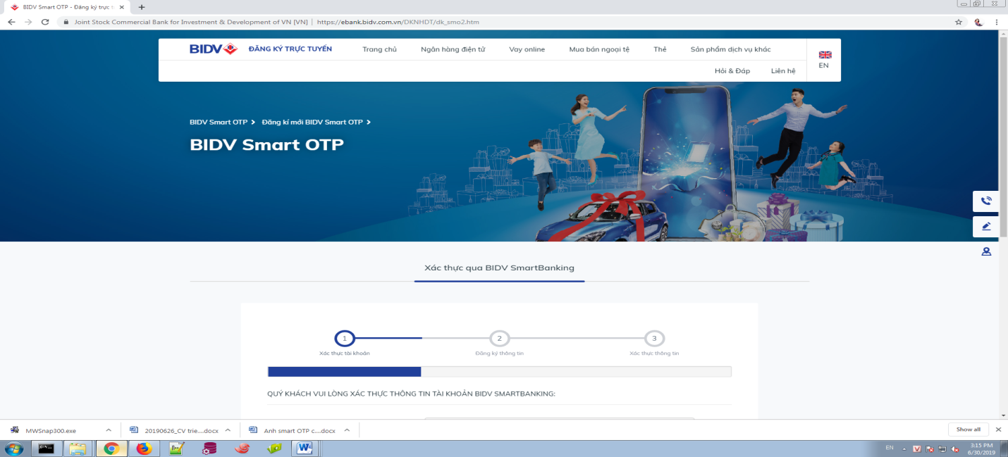
Step 1:
Enter the link https://ebank.bidv.com.vn/DKNHDT/dk_smo2.htm at the address bar of a web browser.
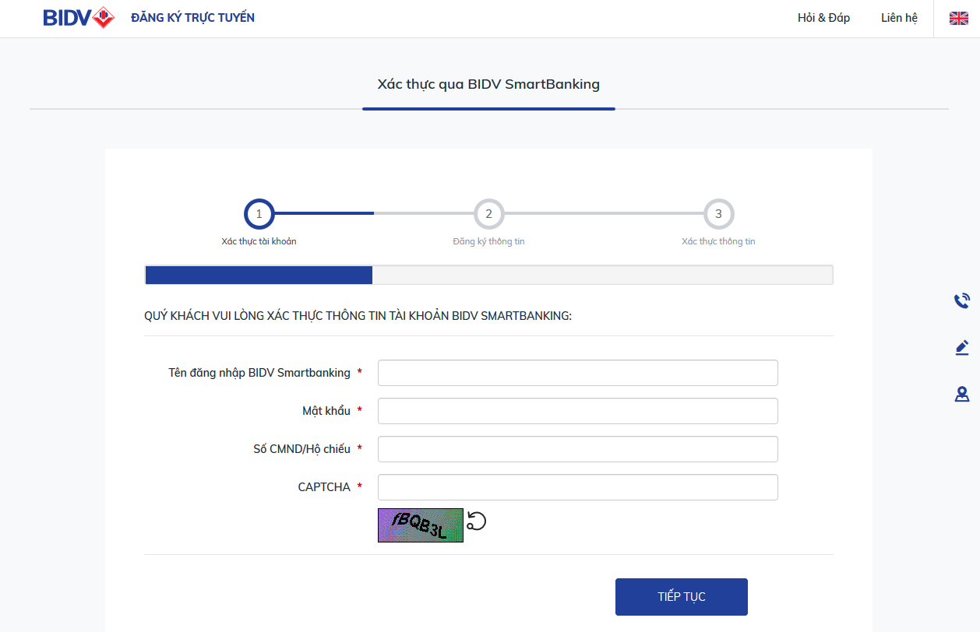 | 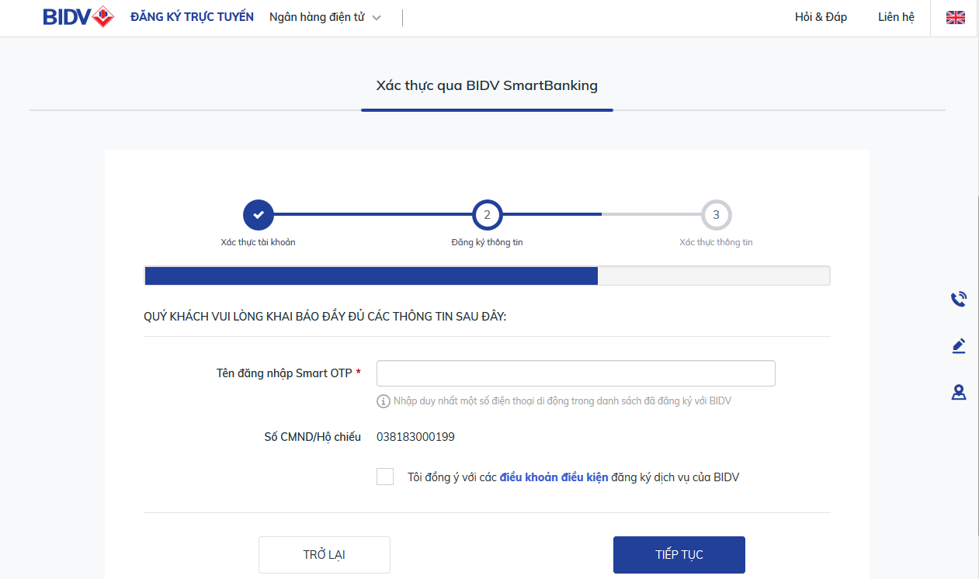
Step 2:  At the Account authentication screen, fill in all required fields: BIDV SmartBanking User name/password; ID/Passport number as registered at BIDV and CAPTCHA as displayed on the screen, then click Continue | Step 3:  At the information registration screen, input registered phone number, which is also the User ID for Smart OTP and click Continue  Note: registered phone number to be used as User ID on Smart OTP must be the same number as provided to BIDV
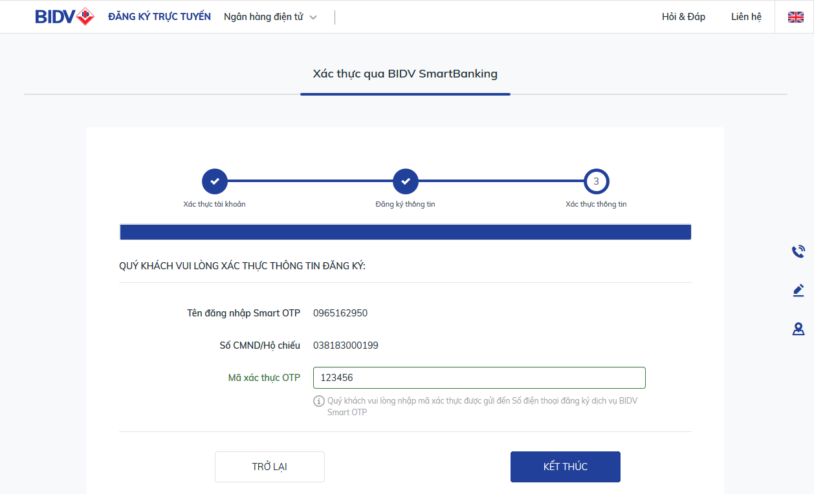 | 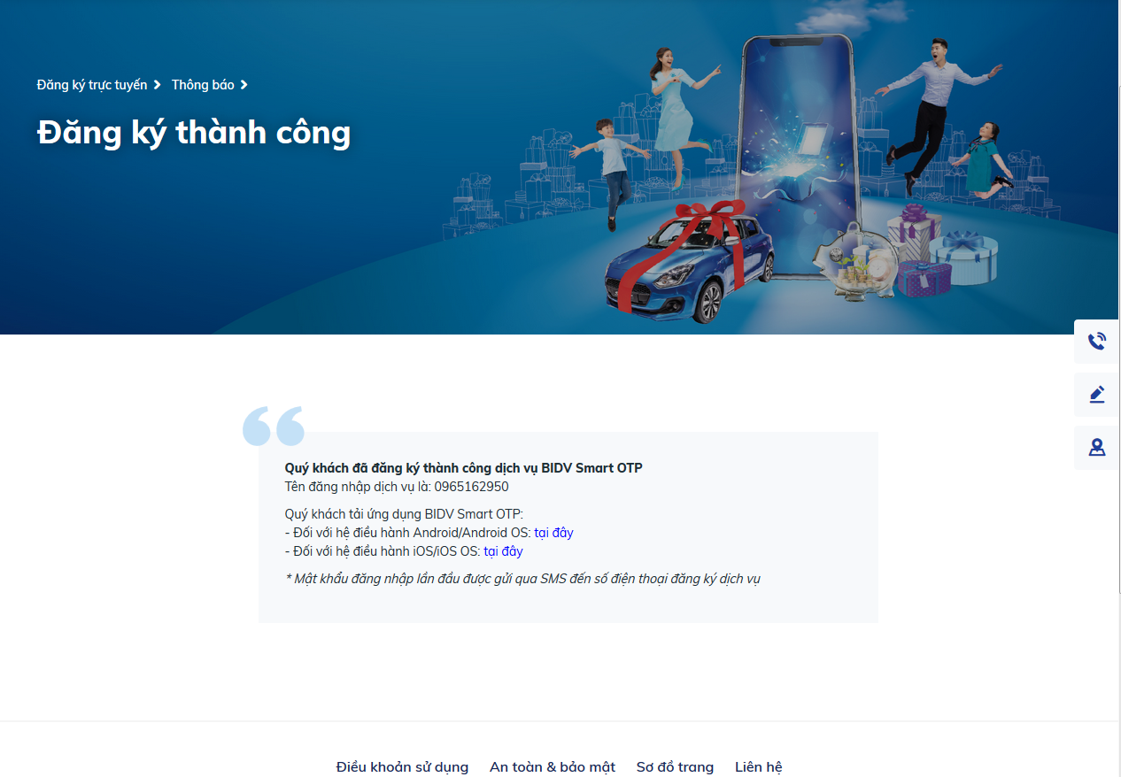
Step 4:  At the Information verification screen, input OTP code which has been sent to the registered phone number – also the Smart OTP ID as provided in Step 3, click Continue | Step 5:  The system displays successful registration result with User ID information, at the same time password is sent via SMS to the registered phone number, which is also the User ID.  Note: User ID and password are only valid for 45 days after the registration date. After the 45 days, customers must visit the bank’s counter for new password.
2. Activate BIDV Smart OTP App
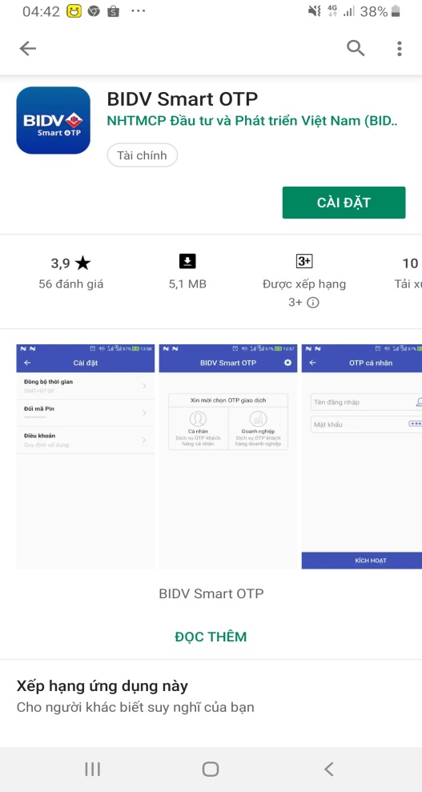 | 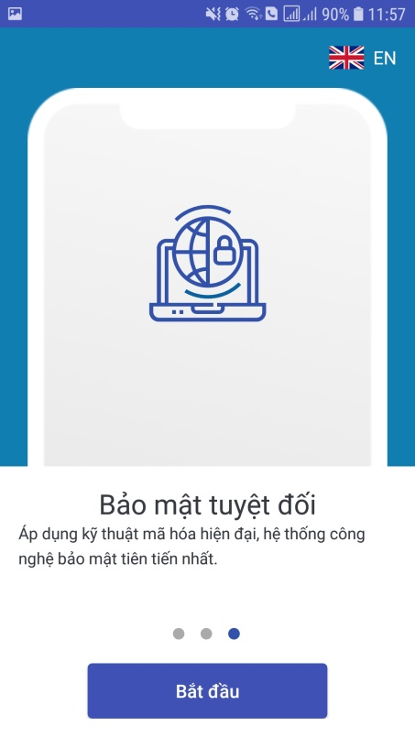 | 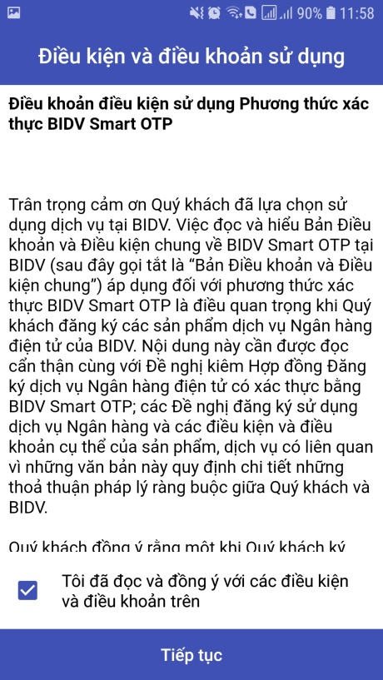 |  | 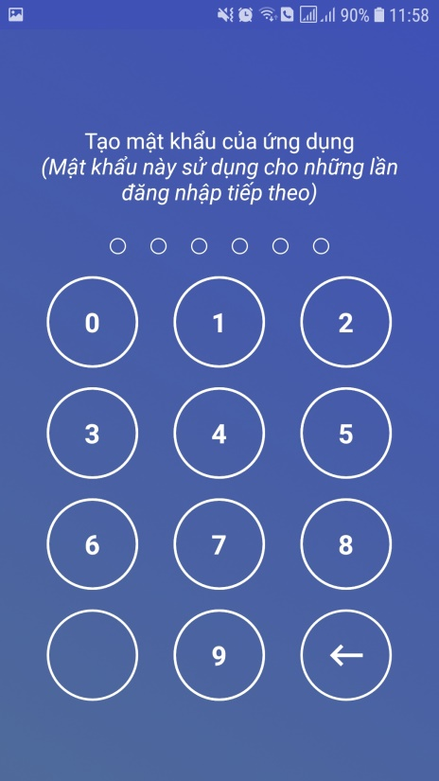
Step 6:  Customer can search and download BIDV Smart OTP app on Google Play, App Store | Step 7:  - Open BIDV Smart OTP app; the app screen shall display service introduction slides  - At the third slide, choose Start, the app screen shall display general terms and conditions  - Scroll down until find the checkbox “I have read and agreed with the above terms and conditions”, tick on the checkbox and click Continue |  |  | Step 8:  Create a password to open BIDV Smart OTP app for the first time
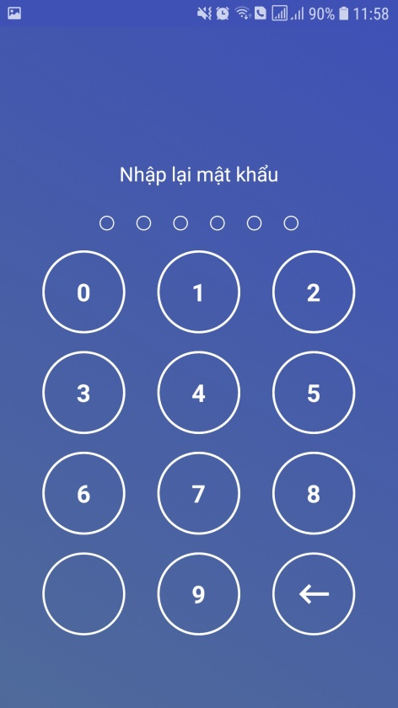 | 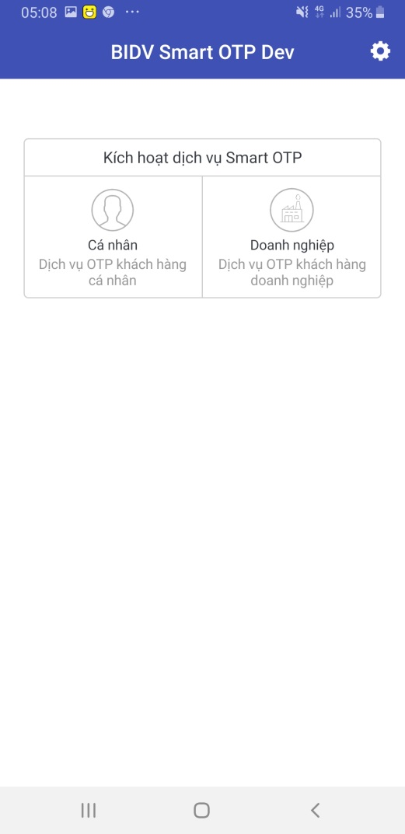 | 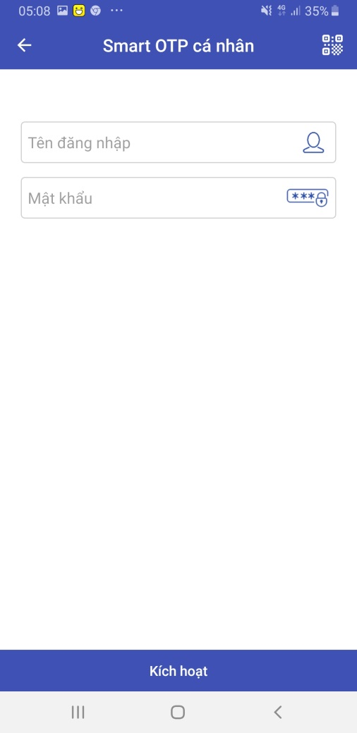 |  | 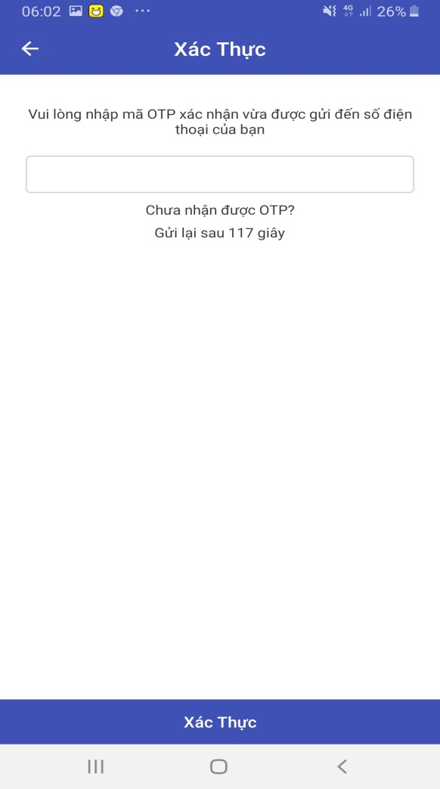
Step 9:  Re-enter password to open BIDV Smart OTP for the second time | Step 10:  At the Smart OTP activation screen, choose Individual customer | Step 11:  At the Smart OTP login screen, enter User ID and password, which has been sent via SMS to the registered phone number – also the User ID, then click Activate |  | Step 12:  At the Authentication screen, enter OTP code, which has been sent via SMS to the registered phone number – also the User ID, then click Authenticate
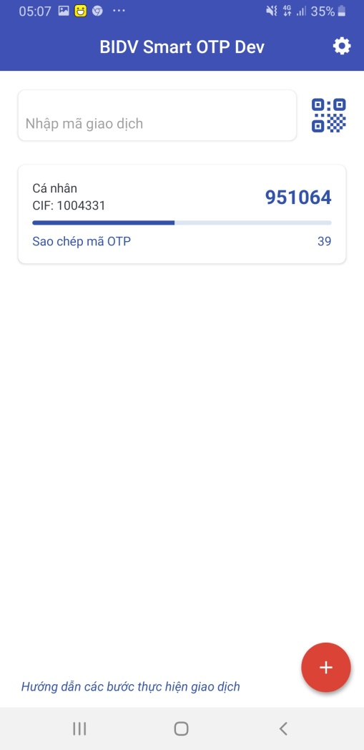
Step 13:
The app displays Home screen, including information about customer CIF number at BIDV and random OTP
Randomly generated OTP is used in non-financial transaction, such as: Logon BIDV Smartbanking on another device; Finger print/FaceID settings, etc.

3. Convert to Smart OTP authentication method via BIDV Smartbanking app
3.1 For customers who have updated BIDV SmartBanking app latest version (Android: 3.5.0.2; iOS: 3.3.3)
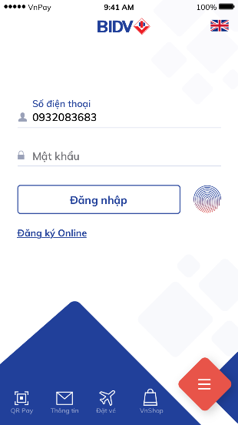 | 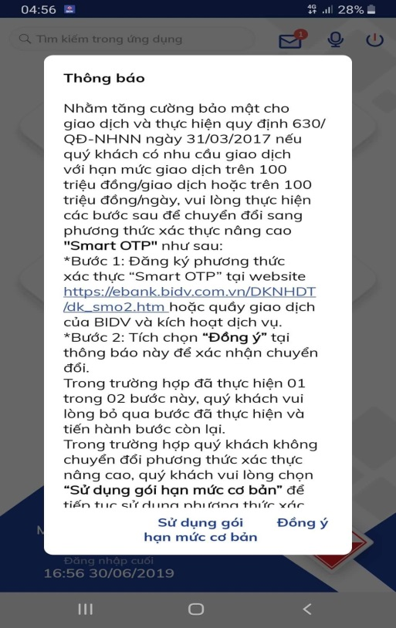  Image 3.1a: Change notification | 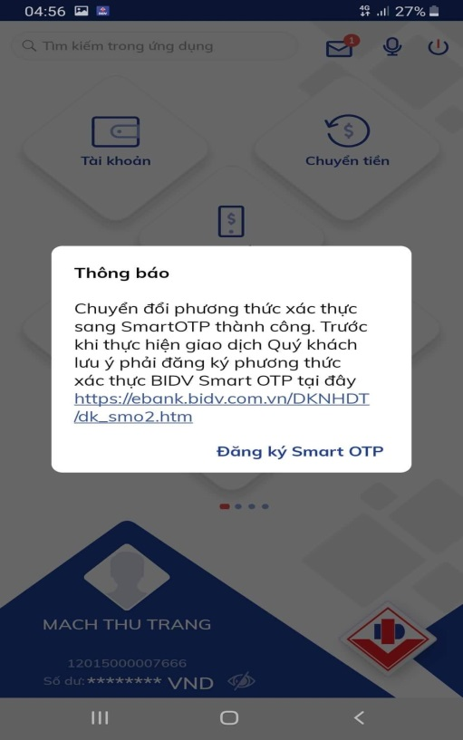  Image 3.1b: Customer agrees to change |  | 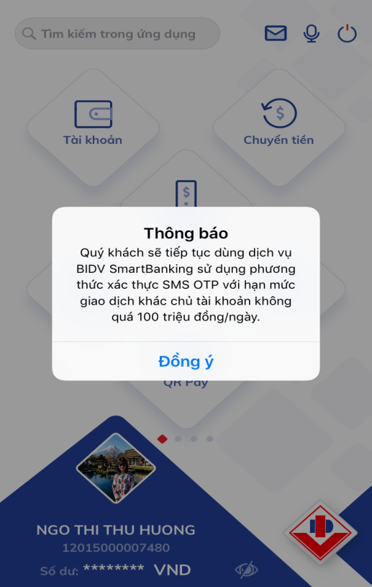  Image 3.1c: Customer uses standard limit package
Step 1:  Open BIDV Smart Banking App and login  Note: Users currently using SMS OTP and service package are required to convert to Smart OTP | Step 2:  The app displays popup notification to change the authentication method (Image 3.1a)  Click “Agree”: Customer shall be switched to Smart OTP authentication => In the next notification screen (Image 3.1b), click the registration link on the notification or tick on “Smart OTP Registration” to switch to the Smart OTP authentication registration screen as instructed in Item 1 of this Appendix  Click “use standard limit package”: customer shall be entitled to use the standard limit package, with transaction limit of up to VND 100million/day, with the SMS OTP authentication method being maintained (notification screen as shown in Image 3.1c).
3.2 For customers who have not updated BIDV SmartBanking app latest version (Android: 3.5.0.2; iOS: 3.3.3)
 | 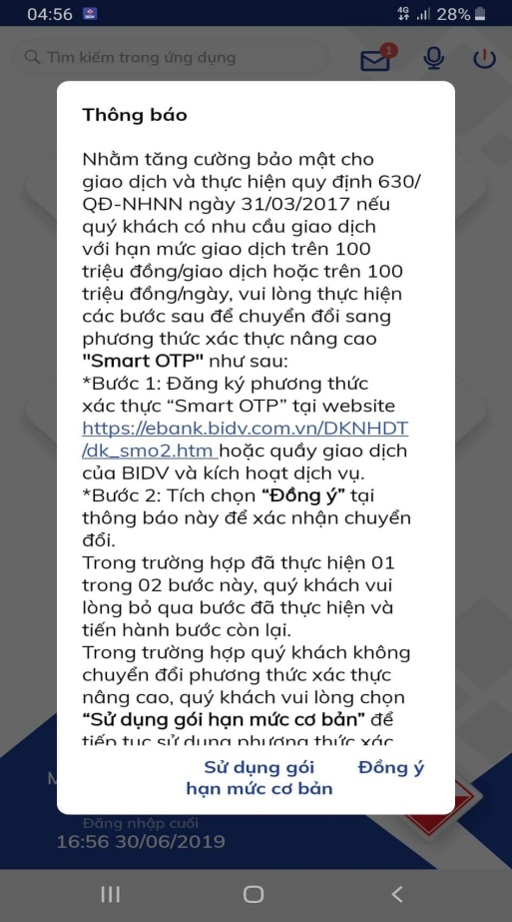  Image 3.2a: Switch notification | 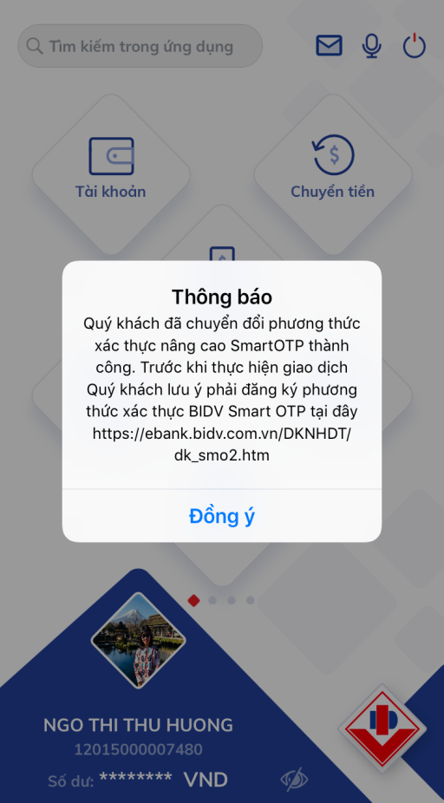  Image 3.2b: Customer agrees to switch |  | 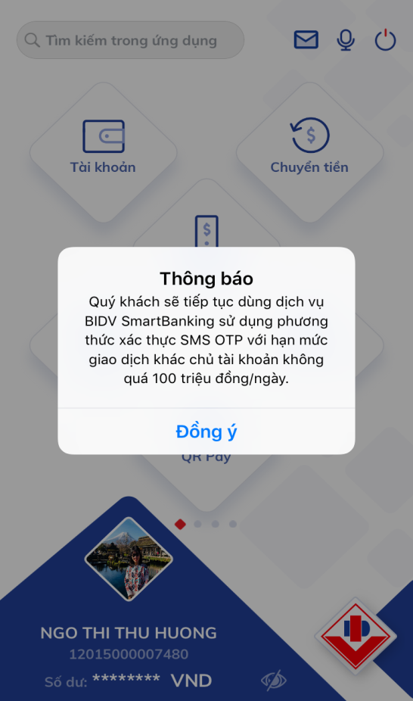  Image 3.2c: Customer uses standard limit package
Step 1:  Open BIDV Smart Banking App and login  Note: Users currently using SMS OTP and service package are required to convert to Smart OTP | Step 2:  The app displays popup notification to change the authentication method (Image 3.2a)  - If customer wishes to convert to the advanced “Smart OTP” authentication method, please follow these steps:  + Click the link https://ebank.bidv.com.vn/DKNHDT/dk_smo2.htm on Step 1 of this notification (Image 3.2a) to convert to OTP authentication method  + After conversion following the above link, on the Smart Banking App, at the Popup notification screen 3.2a, click “Agree”  - If customer does not want to switch to the advanced Smart OTP authentication method, click on “use standard limit package” and shall be directed to standard limit package, with total transaction value of up to VND 100million/day, SMS OTP verification method being maintained (notification screen displays Image 3.2c).
4. Guidelines to conduct financial transaction using Smart OTP authentication on BIDV SmartBanking app
 | 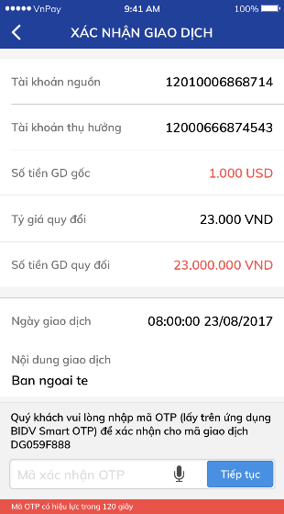
Step 1:  Generate financial transaction  Input all required info fields, then click Continue | Step 2:  On the transaction confirmation screen, enter OTP  - Transaction code is displayed, used to generate OTP |  | Step 3:  Click on Transaction code notification to open and automatically fill transaction code on BIDV Smart OTP App.  In case of not receiving notification, customer may click Transaction code checkbox on the confirmation screen of BIDV SmartBanking for automatic copy support; then open Smart OTP app to paste to Transaction code box. (For BIDV SmartBanking App on Android, the system shall support automatic filling of Transaction code when opening Smart OTP app). |  | Step 4:  On the transaction confirmation screen, input OTP, enter OTP as displayed on Smart OTP app, then click Continue to complete the transaction

