Guideline of Smart OTP
- Instructions for installing applications
You download and install app “BIDV Smart OTP” from App Store for devices that run iOS operating system and Google Play for ones that run Android operating system.
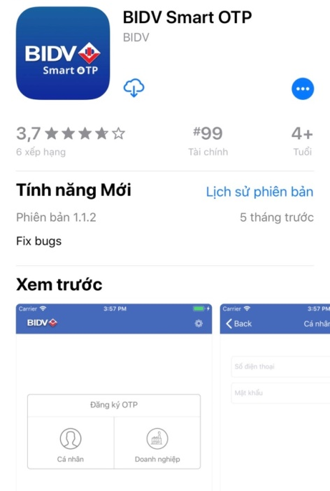 | 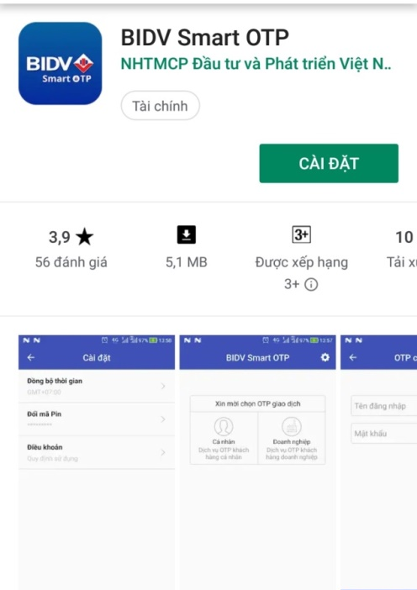
Or using QR code reader application to scan QR code for iOS and Android below):

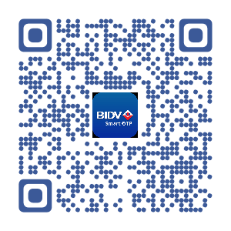 | 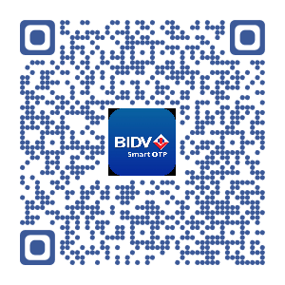

- Instructions for the first signing in.
Step 1: After finishing the installation, you open the application, the introductions and Terms and conditions will be shown:
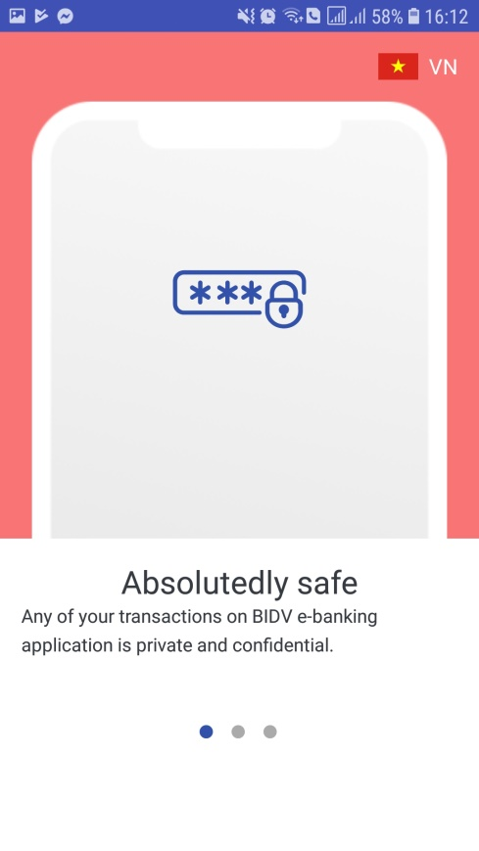 | 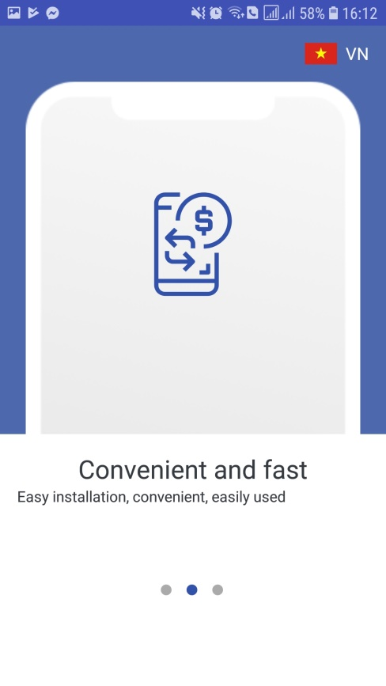 | 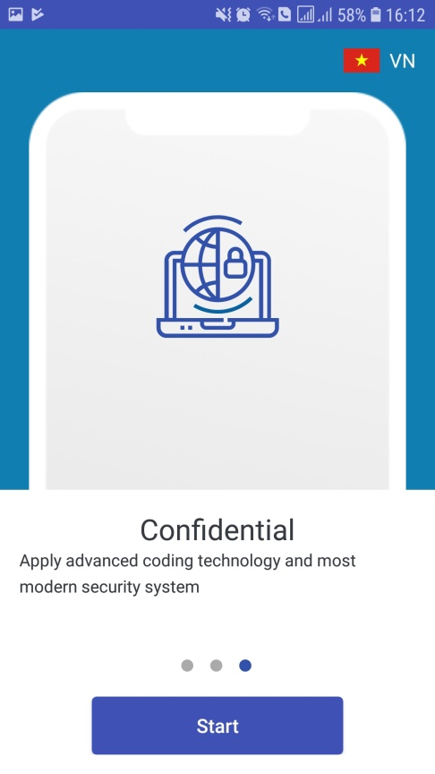

You can choose to display in English ( EN) or Vietnammese ( VI)
You read and select “I agree with the terms and conditions”, then select “Continue”
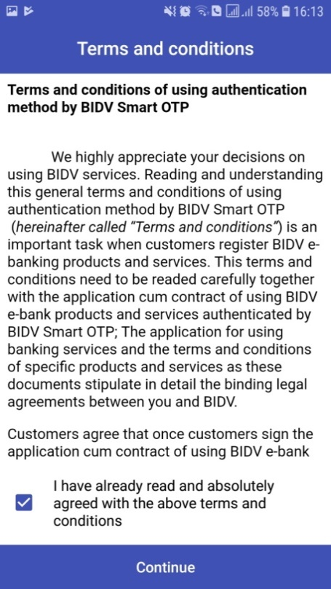
Step 2: Set the application password – this is the password signing in the app for the following logins.
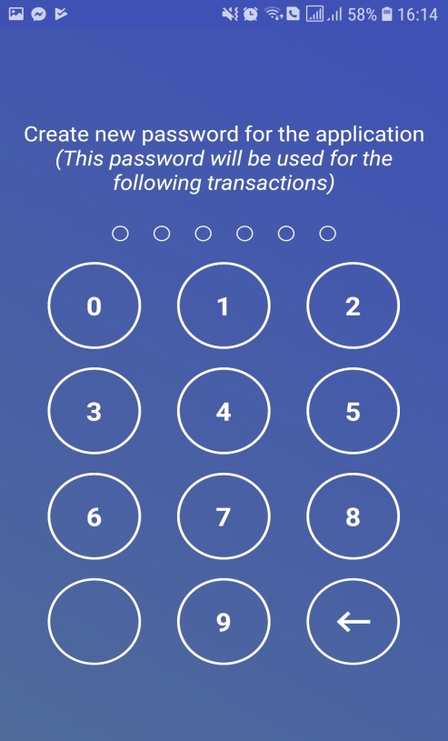 | 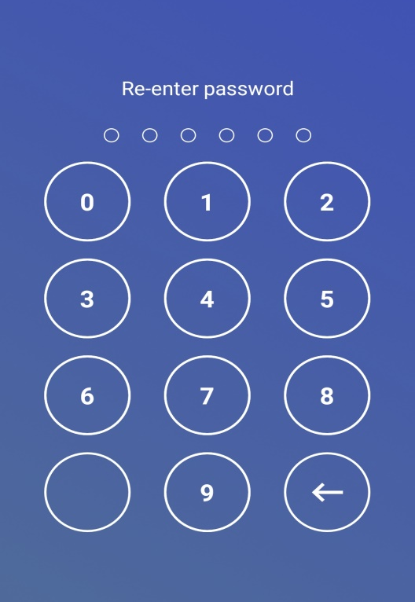

Step 3: Select to activate services for Individuals/Enterprises
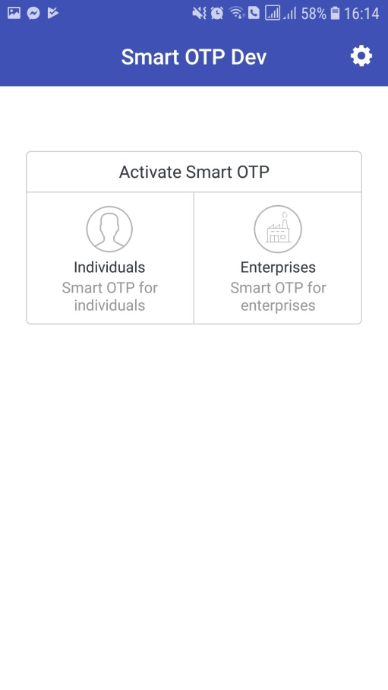
Step 4: Sign in Account Informations by user name and Password that BIDV provided, or received via email registered or SMS message.
Notice: Account Informations is valid withins 45 days from the date of registration. After 45 days, please contact BIDV branch to request a new password.
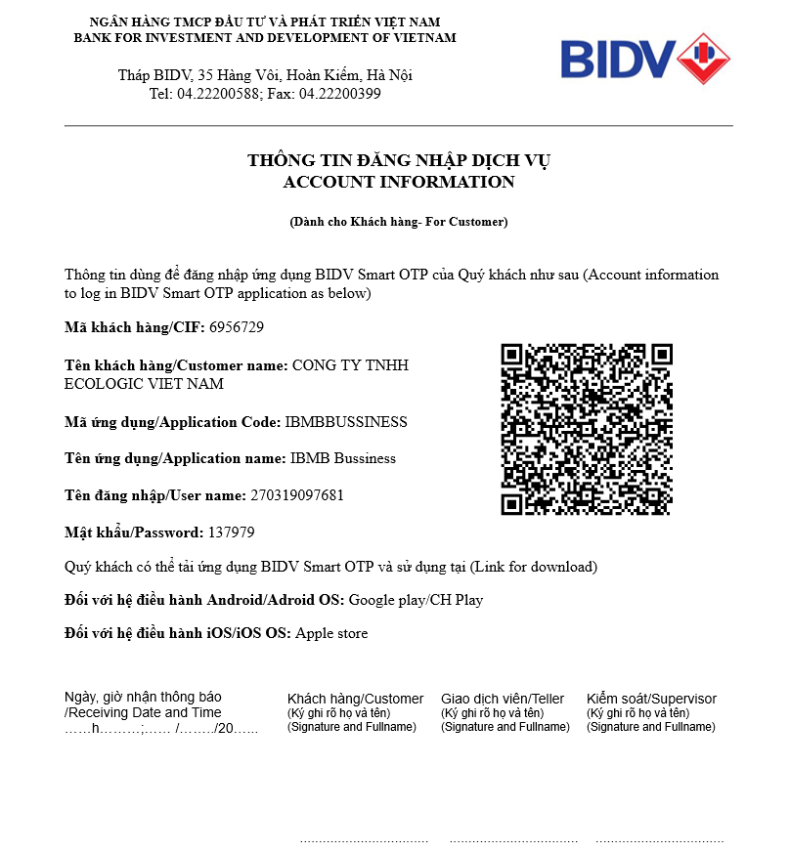
You can choose one of two methods:
Method 1: Input User name/Password to User name/Password box, then select “Activate”.
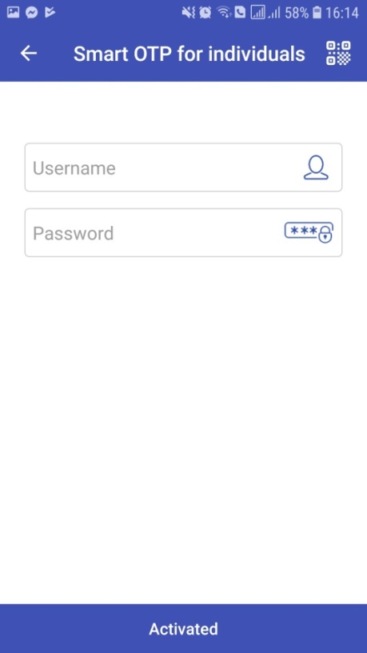 | 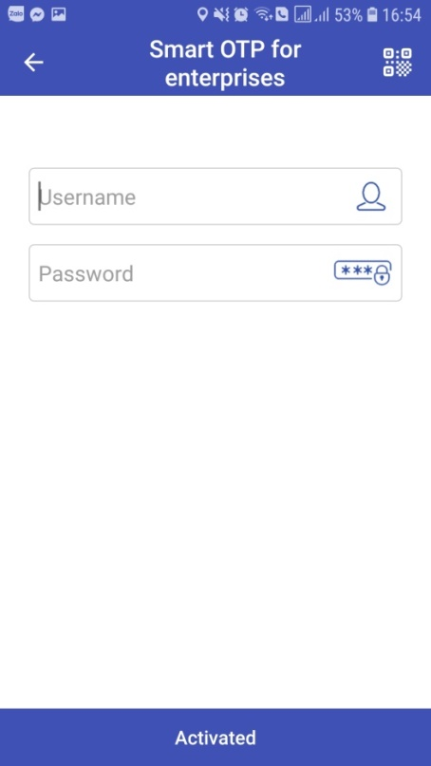

Method 2: Use the QR Code function to capture QR Code that displayed in the Account informations.
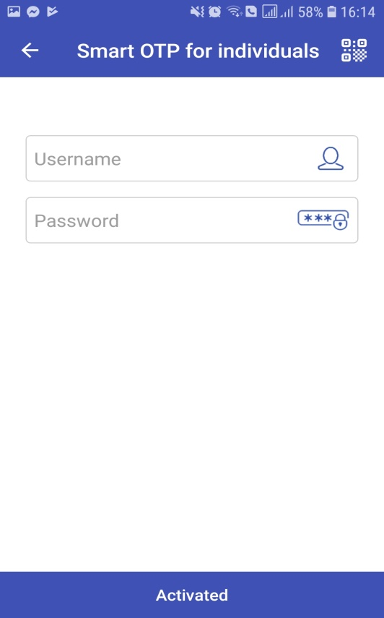 | 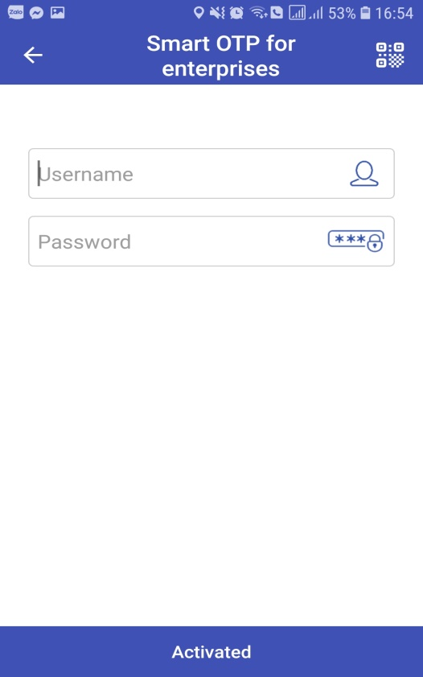

Notice: In order to use this function, you set up the device settings that allow Smart OTP to take photos and record video.
After inputting Username/Password, select “Activate”.
Step 5: If informations is authenticated, the app switchs to the inputting activated code screen. The Active code is automatically sent to customer’s registered mobile number. In case you doesn’t receive the message containing the Activated code in 120 seconds, you choose “Resend Activated Code”.
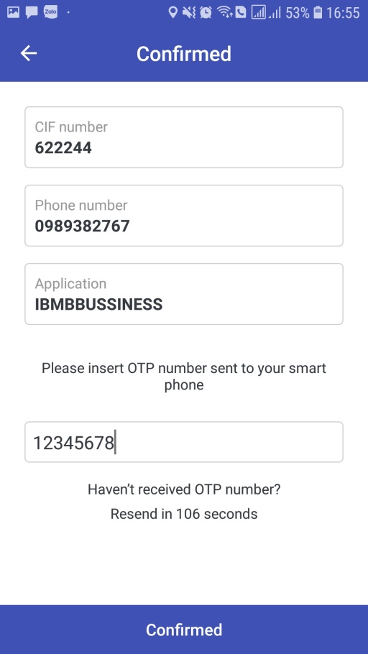
Input OTP Activated Code to activate the services.
Notice: this activated code is valid for a span of 5 minutes. After this time, choose Resend OTP to get a new one.
Your Account Informations has been disabled after 10 unsuccessful attempts to input activated code. In this case, please contact BIDV branch to request a new one.
Step 6: Go into the app screen to complete the activating process.
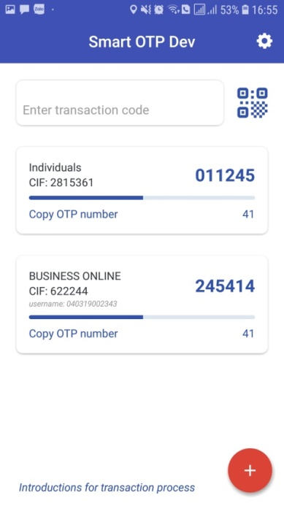
Add new Smart OTP user
OTP number
Each application has maximum one actived individual user.
In case you want to declare more Smart OTP user (e.g: iBank, Business Online) on the same application, you select “the plus” on the right corner of the screen and make a declaration at step 4. List of activated Smart OTP users is displayed on the main screen of Smart OTP app.
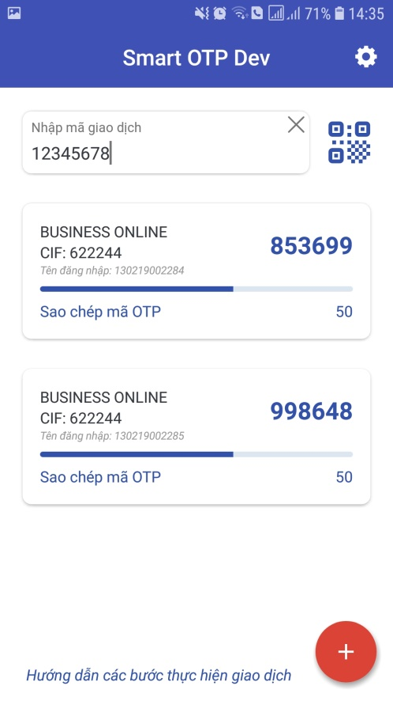

- Instructions for login (not the first login)
Step 1: Open the app, input the password set for the first time login.
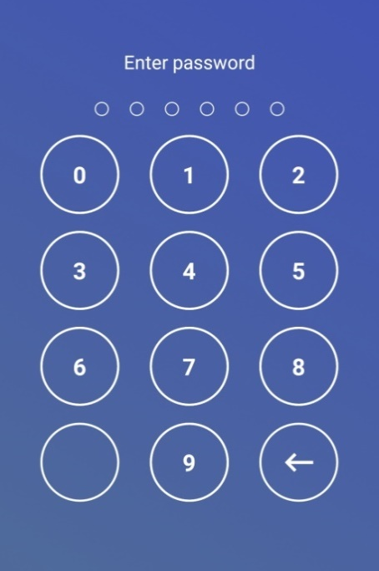
Step 2: The Smart OTP screen display:
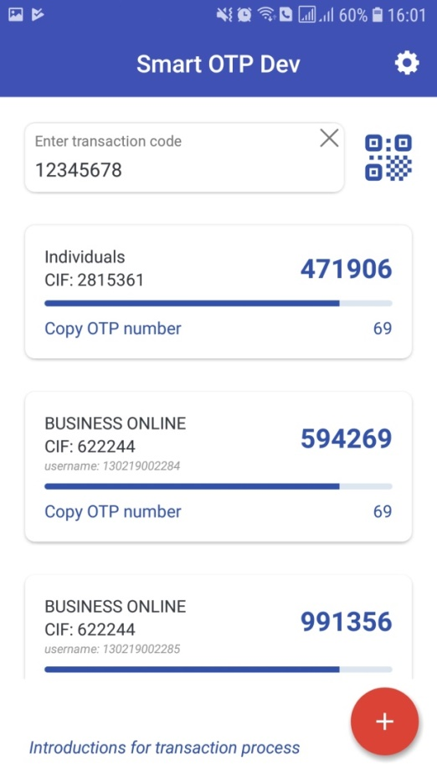

Transaction Code that corresponding with the Transaction in processing is automatically displayed on Smart OTP app.
In case the transaction code isn’t displayed, you can input it manually or use QR code function to capture QR code on the screen that you are processing the transaction.
Transaction code is displayed as below:
- BIDV Online, Business Online, Smart Banking: text format.
- BIDV iBank: both text and QR format.

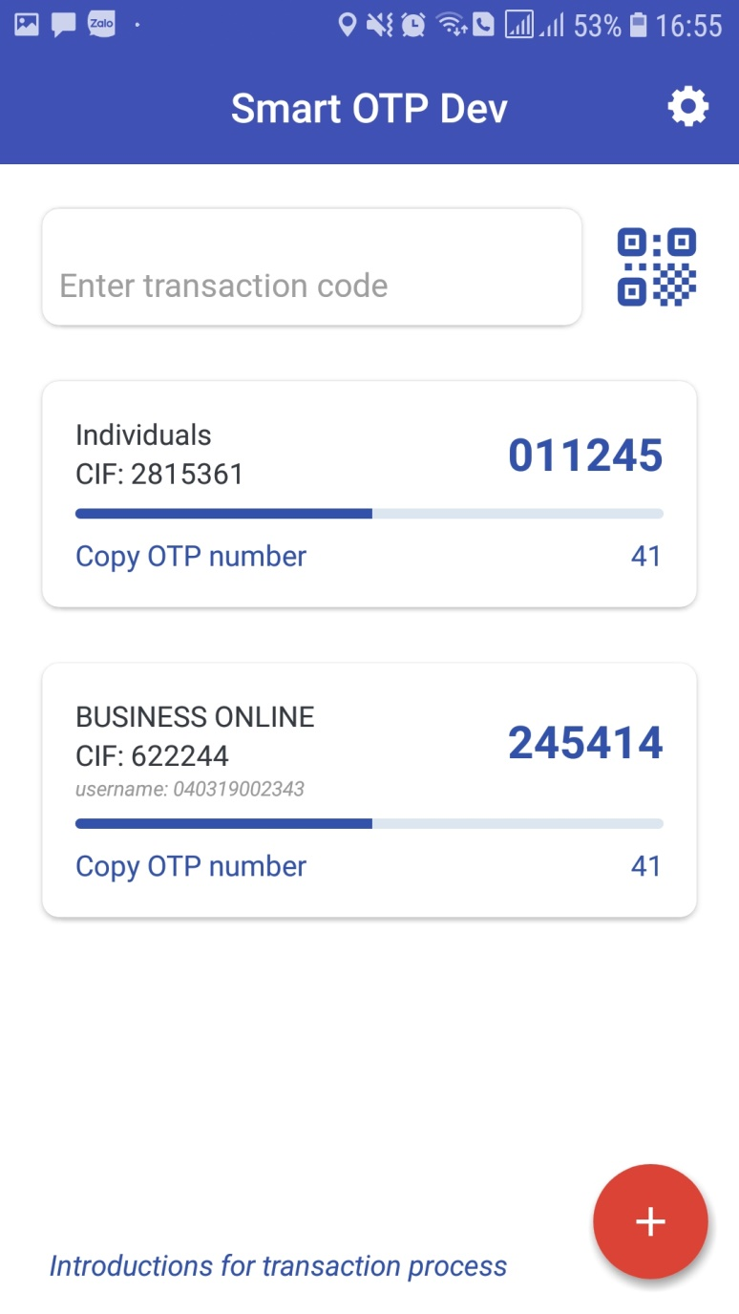
QR code function
- Smart OTP Setting Function.
Smart OTP has the function that set up the application features, including Language, Change PIN code, synchronize Time and View user terms.
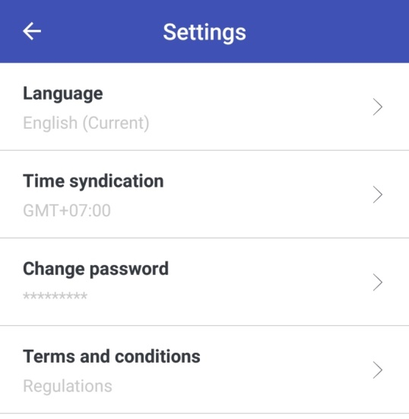
- Language: choose one of two displayed languages English or Vietnamese.
- Change password:
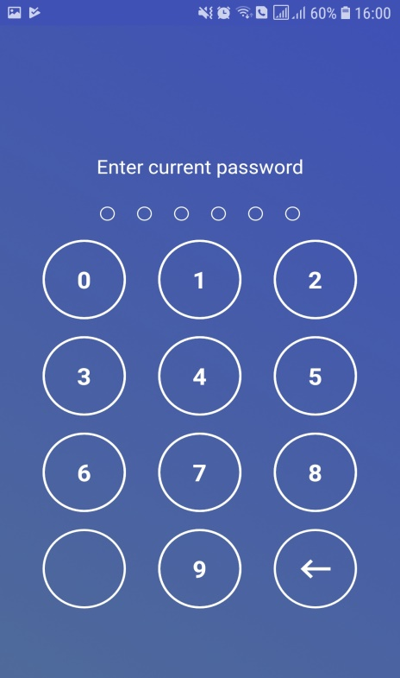 | 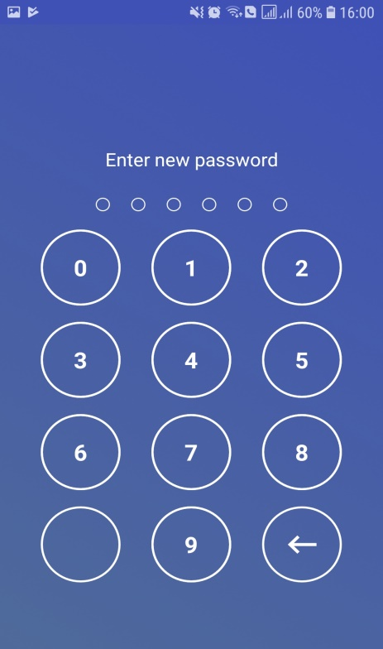 | 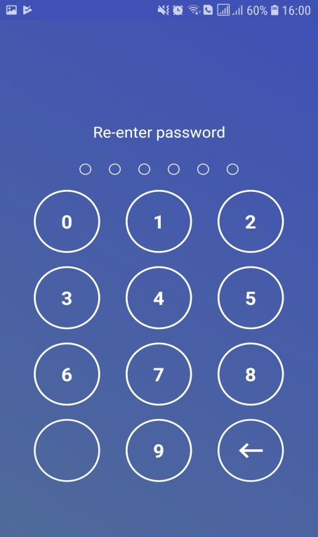
- Terms: see terms and conditions
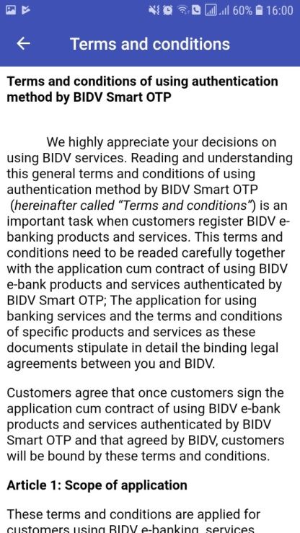
- Time Syndication: this function is used to fix the failure to authenticate financial transaction by Smart OTP due to the time on the device which Smart OTP be installed and the time on Smart OTP application is mismatched .

